**FLIPKART**

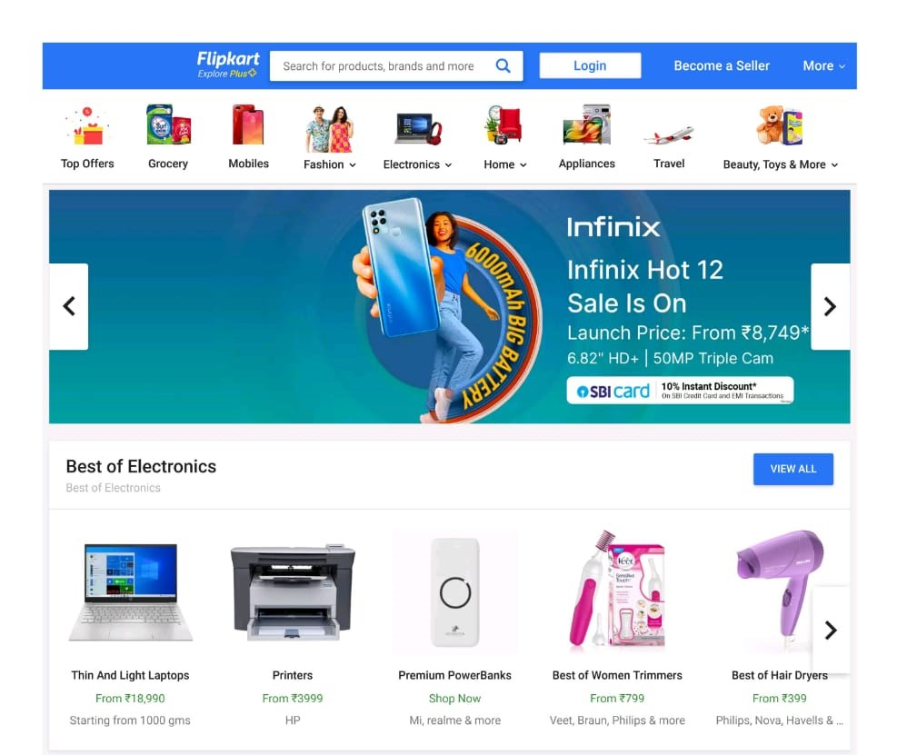

**OverView :**

**Flipkart** is an Indian e-commerce company, headquartered in Bangalore,and incorporated in Singapore as a Private Limited Company.

The company initially focused on online book sales before expanding into other product categories such as consumer electronics, fashion, home essentials, groceries, and lifestyle products.

**History :**

Flipkart was founded in October 2007 by **Sachin Bansal** and **Binny Bansal**, alumni of the IIT Delhi and former Amazon employees. The company initially focused on online book sales with country-wide shipping.

With its eyes on India's retail market, Flipkart acquired Letsbuy, an online electronics retailer, in 2012, and **Myntra**, an online fashion retailer, for US$280 million in May 2014.

On 4 May 2018, it was reported that **Walmart** had won a bidding war with Amazon to acquire a majority stake in Flipkart for US$15 billion. On 9 May 2018, Walmart officially announced its intent to acquire a 77% controlling stake in Flipkart for US$16 billion. Following the purchase, Flipkart co-founder Sachin Bansal left the company.

On 13 November 2018, Flipkart CEO Binny Bansal resigned.

**Goals :**

1. Login page
2. Home Page
3. Item List Page
4. Payment page

**Home Page :**

1. Logo
2. Search Bar
3. Add to cart
4. Slider
5. Deals of the Day ( Images )
6. Featured ( Images )
7. Trending ( Images )
8. Footer ( About, Help, Policy, Social, Mail Us, Registered Office Address, ..)

**Registration Page:**

1. Mobile Number
2. E-mail ID
3. Flipkart Plus

**Item’s List Page :**

1. Sort By
   1. Popularity
   2. Price - - Low to High
   3. Price - - High to low
   4. Newest First
2. Filters
   1. Brand
   2. Color
   3. Price
   4. Discount
   5. Rating
   6. Pattern
   7. Size
   8. Offers
   9. Availability
3. Each Item is divided into Separate divisions.
4. Images of each product with details & Option to Buy Now / Add to cart

(Product Name, Brand, Price, Rating)

1. On Click, the images of a product appears in different angles
2. On Click, Product description
   1. Product Name
   2. Brand
   3. Version
   4. Price
   5. Rating
   6. Size chart
   7. Customer reviews
   8. Related products
3. Share or Compare

**Payment Page :**

1. Address
2. Payment Method
   1. Phone Pe
   2. Google Pay
   3. BHIM UPI
   4. Credit / Debit Card
   5. Net - Banking
   6. EMI
   7. Paytm